**YAYASAN SASMITA JAYA**

** UNIVERSITAS PAMULANG**

**SK MENDIKNAS NO. 143/D/0/2006**

**Jl. Surya Kencana No.1 Pamulang – Tangerang Selatan, Banten Telp./Fax. (021) 741 2566**

|  |  |  |  |  |  |
| --- | --- | --- | --- | --- | --- |
| Mata Kuliah | : | **UJIAN TENGAH SEMESTER**  Sistem Penunjang Keputusan | Nama | : | Muhammad Thaariq Wirayudha |
| Fak/Jurusan | : | Teknik Informatika | Nim | : | 181011401277 |
| Semester | : | 7 (Tujuh) | Kelas | : | 07TPLE013 |
| Dosen | : | Agung Perdananto, S.Kom., M.Kom. | Tanggal | : | 19 november 2021 |
|  |  |  | Shift | : | Reguler C ( Sabtu) |

Link Jupyter: <http://localhost:8888/notebooks/Muhammad%20Thaariq%20Wirayudha_181011401277_UTS_SPK_07TPLE013.ipynb>

Link github :

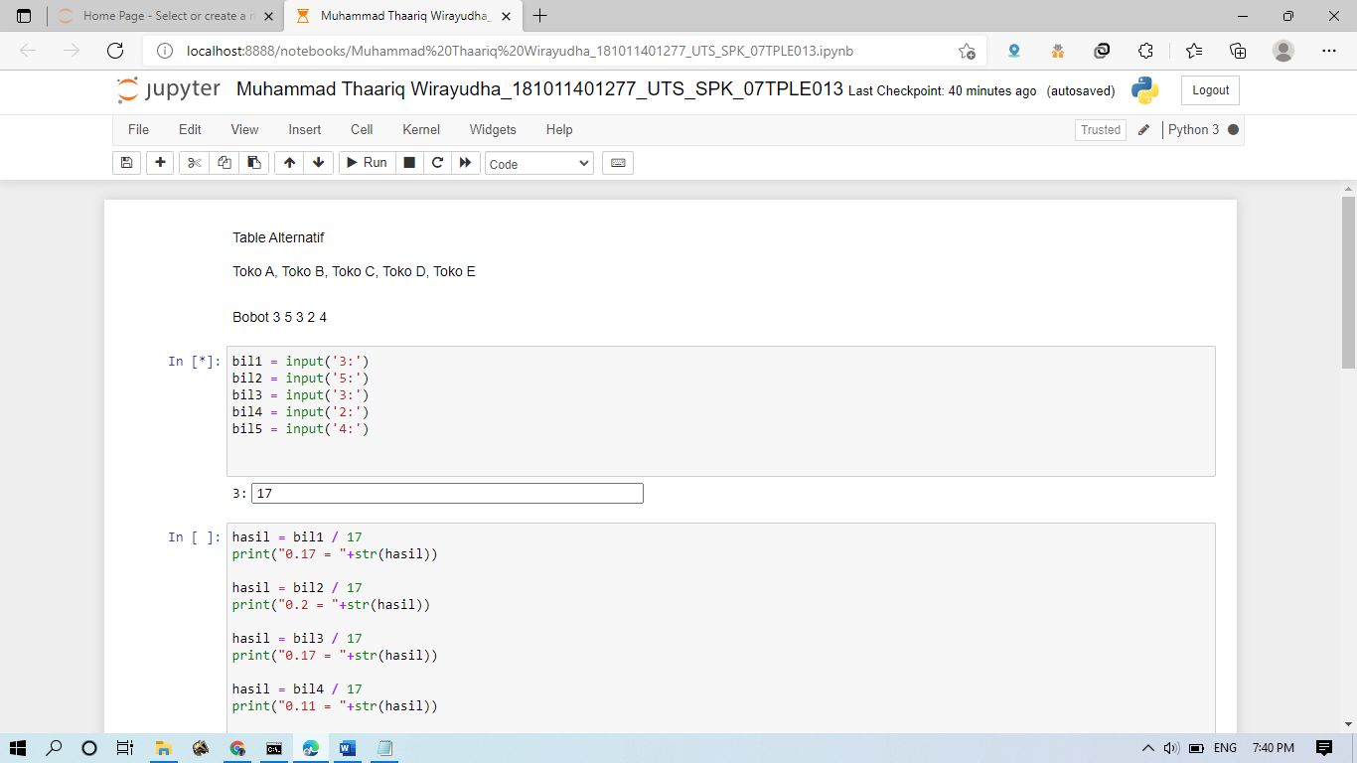

**YAYASAN SASMITA JAYA**

** UNIVERSITAS PAMULANG**

**SK MENDIKNAS NO. 143/D/0/2006**

**Jl. Surya Kencana No.1 Pamulang – Tangerang Selatan, Banten Telp./Fax. (021) 741 2566**

|  |  |  |  |  |  |
| --- | --- | --- | --- | --- | --- |
| Mata Kuliah | : | **UJIAN TENGAH SEMESTER**  Sistem Penunjang Keputusan | Nama | : | Muhammad Thaariq Wirayudha |
| Fak/Jurusan | : | Teknik Informatika | Nim | : | 181011401277 |
| Semester | : | 7 (Tujuh) | Kelas | : | 07TPLE013 |
| Dosen | : | Agung Perdananto, S.Kom., M.Kom. | Tanggal | : | 19 november 2021 |
|  |  |  | Shift | : | Reguler C ( Sabtu) |

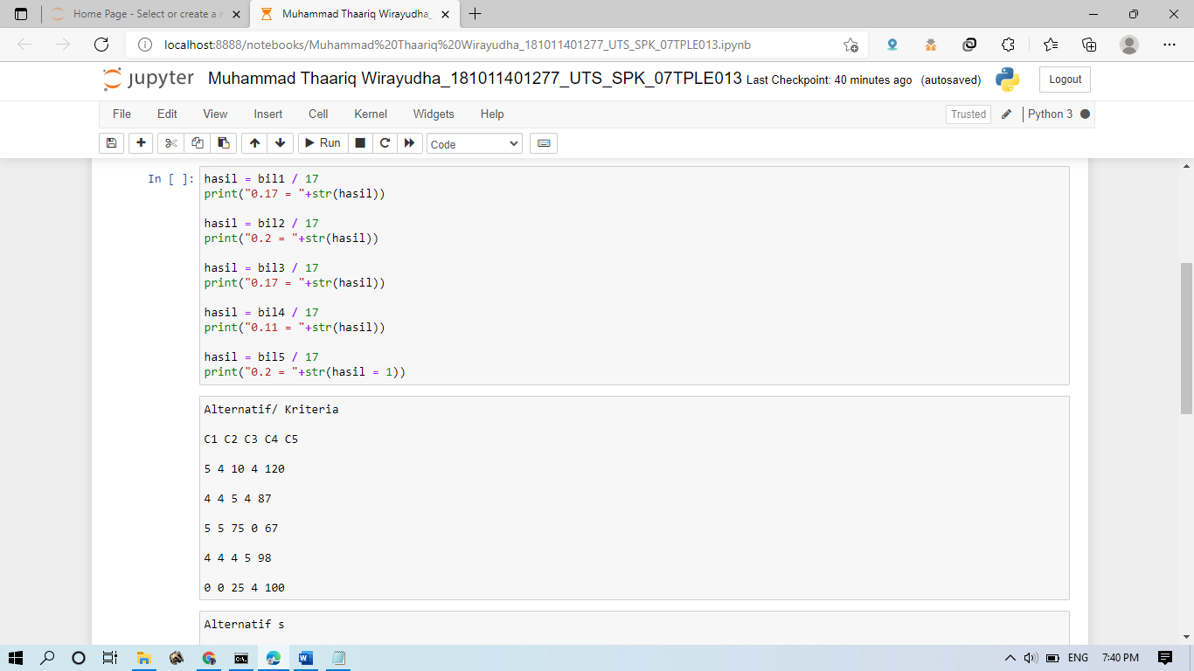

**YAYASAN SASMITA JAYA**

** UNIVERSITAS PAMULANG**

**SK MENDIKNAS NO. 143/D/0/2006**

**Jl. Surya Kencana No.1 Pamulang – Tangerang Selatan, Banten Telp./Fax. (021) 741 2566**

|  |  |  |  |  |  |
| --- | --- | --- | --- | --- | --- |
| Mata Kuliah | : | **UJIAN TENGAH SEMESTER**  Sistem Penunjang Keputusan | Nama | : | Muhammad Thaariq Wirayudha |
| Fak/Jurusan | : | Teknik Informatika | Nim | : | 181011401277 |
| Semester | : | 7 (Tujuh) | Kelas | : | 07TPLE013 |
| Dosen | : | Agung Perdananto, S.Kom., M.Kom. | Tanggal | : | 19 november 2021 |
|  |  |  | Shift | : | Reguler C ( Sabtu) |

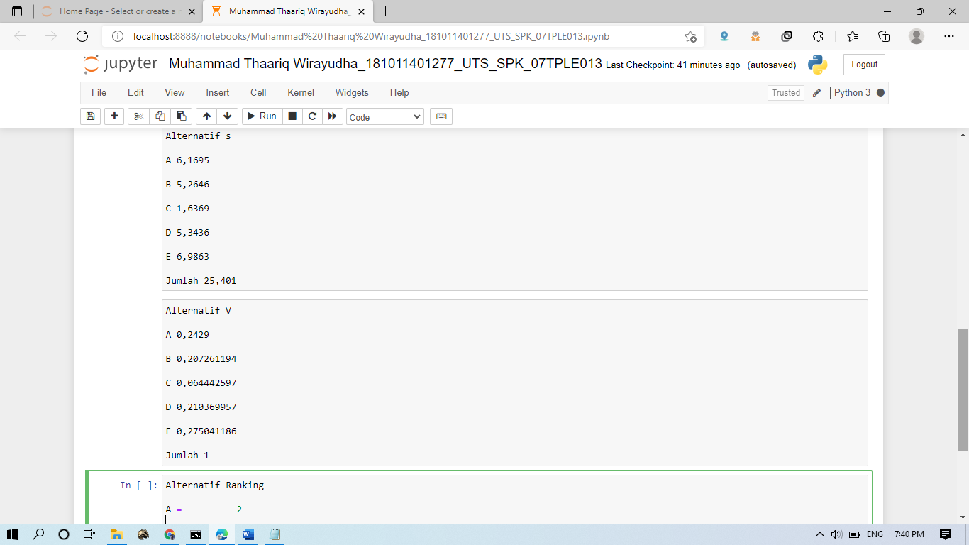

**YAYASAN SASMITA JAYA**

** UNIVERSITAS PAMULANG**

**SK MENDIKNAS NO. 143/D/0/2006**

**Jl. Surya Kencana No.1 Pamulang – Tangerang Selatan, Banten Telp./Fax. (021) 741 2566**

|  |  |  |  |  |  |
| --- | --- | --- | --- | --- | --- |
| Mata Kuliah | : | **UJIAN TENGAH SEMESTER**  Sistem Penunjang Keputusan | Nama | : | Muhammad Thaariq Wirayudha |
| Fak/Jurusan | : | Teknik Informatika | Nim | : | 181011401277 |
| Semester | : | 7 (Tujuh) | Kelas | : | 07TPLE013 |
| Dosen | : | Agung Perdananto, S.Kom., M.Kom. | Tanggal | : | 19 november 2021 |
|  |  |  | Shift | : | Reguler C ( Sabtu) |

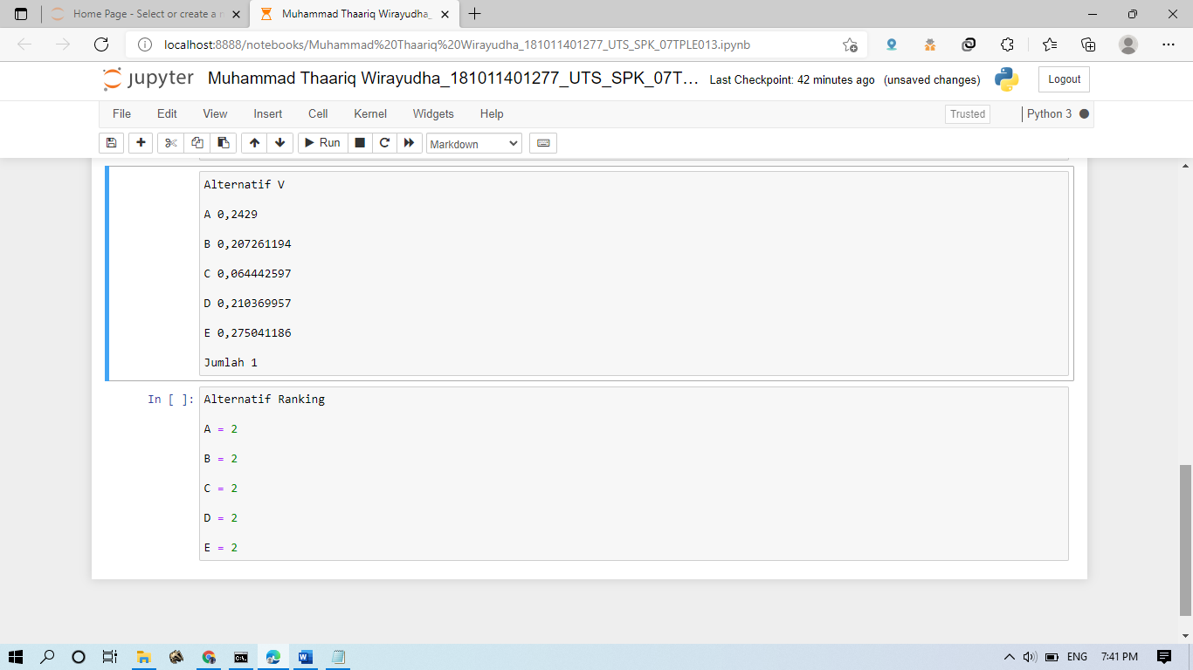

**YAYASAN SASMITA JAYA**

** UNIVERSITAS PAMULANG**

**SK MENDIKNAS NO. 143/D/0/2006**

**Jl. Surya Kencana No.1 Pamulang – Tangerang Selatan, Banten Telp./Fax. (021) 741 2566**

|  |  |  |  |  |  |
| --- | --- | --- | --- | --- | --- |
| Mata Kuliah | : | **UJIAN TENGAH SEMESTER**  Sistem Penunjang Keputusan | Nama | : | Muhammad Thaariq Wirayudha |
| Fak/Jurusan | : | Teknik Informatika | Nim | : | 181011401277 |
| Semester | : | 7 (Tujuh) | Kelas | : | 07TPLE013 |
| Dosen | : | Agung Perdananto, S.Kom., M.Kom. | Tanggal | : | 19 november 2021 |
|  |  |  | Shift | : | Reguler C ( Sabtu) |

Kartu ujian

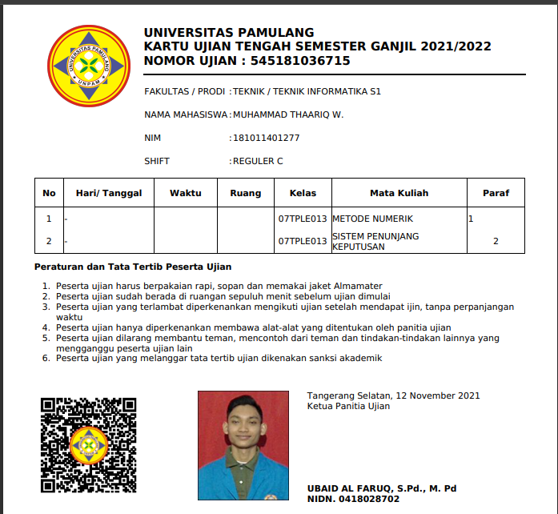

**YAYASAN SASMITA JAYA**

** UNIVERSITAS PAMULANG**

**SK MENDIKNAS NO. 143/D/0/2006**

**Jl. Surya Kencana No.1 Pamulang – Tangerang Selatan, Banten Telp./Fax. (021) 741 2566**

|  |  |  |  |  |  |
| --- | --- | --- | --- | --- | --- |
| Mata Kuliah | : | **UJIAN TENGAH SEMESTER**  Sistem Penunjang Keputusan | Nama | : | Muhammad Thaariq Wirayudha |
| Fak/Jurusan | : | Teknik Informatika | Nim | : | 181011401277 |
| Semester | : | 7 (Tujuh) | Kelas | : | 07TPLE013 |
| Dosen | : | Agung Perdananto, S.Kom., M.Kom. | Tanggal | : | 19 november 2021 |
|  |  |  | Shift | : | Reguler C ( Sabtu) |

Bukti pembayaran

